Amos Lee – Sweet Pea

[Intro] Verse with no vocal

[Verse]
F | A7 | dm | G7/B
F dm | Bb C | F [2x]

[Chorus]
A7 | A7 | dm | dm
G7 | G7 | C | C

[last chord] E F

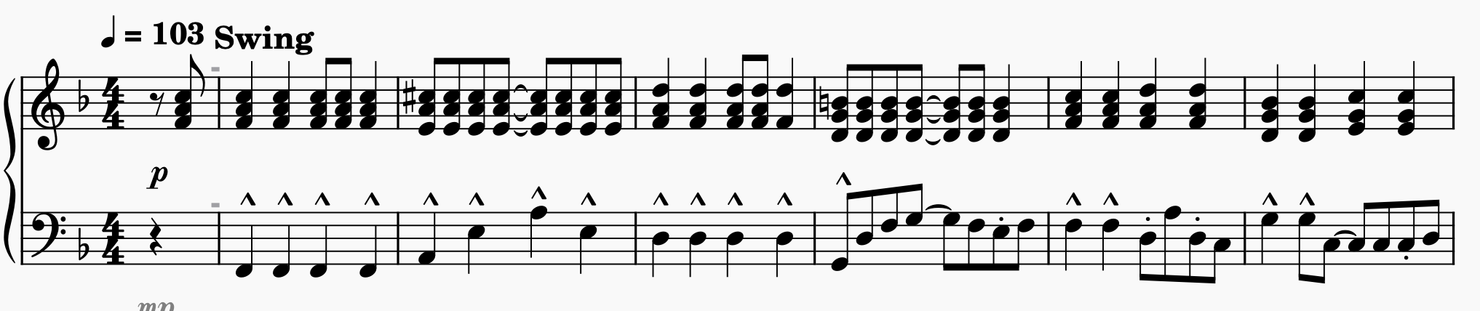
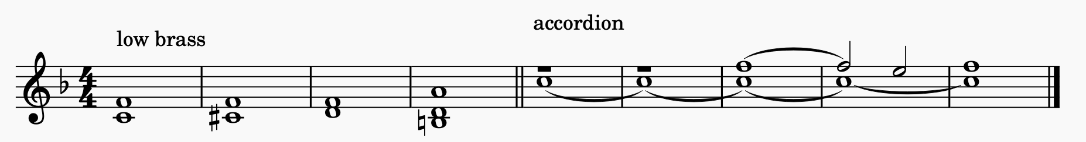
^^^ Brass parts on 2nd & 3rd verses
use Yamaha strings 2 or 3

